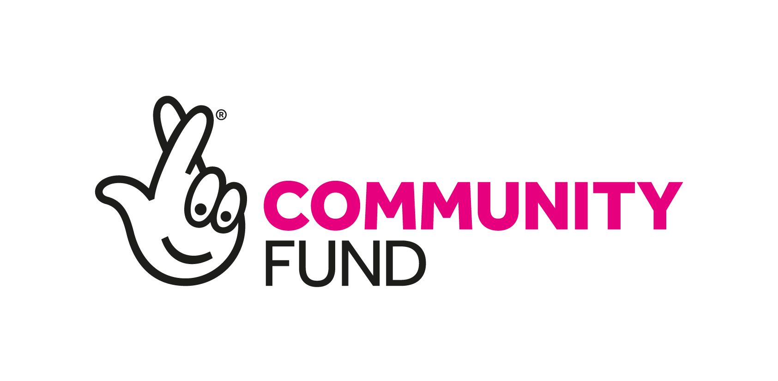

JOB DESCRIPTION

YOUTH ENGAGEMENT CASEWORKER

Reporting to: Advocacy Services Co-ordinator
Role Purpose: The Youth Engagement Caseworker will provide advice, support and empowerment to young people in order tor them to thrive and contribute to matters that affect their lives. This is a new project funded by the National Lottery Community Fund.
Contractual Conditions: The post will necessitate travel throughout East Lothian. There will be a balance of home working and being office based.

Staff Managed: None

Salary Band: £28,000 (35 hours per week) 3 year post January 2025-December 2027

Responsibilities:
- To actively engage with young people and build up trusting relationships with them individually or in groups;
- To carry out support planning, mentoring and aftercare with young people as they progress through their time on the project;
- Encourage young people to partake in advice available to assist them and to participate in partner services relevant to their needs;
- To provide advice, information, and support on relevant issues in the proficient, effective, and understandable manner appropriate to the needs of young people;
- To identify and engage with young people aged 16-25 who are vulnerable and hard to reach;
- Engage and work in partnership with third sector, schools, local authority and other organisations;
- Actively promote the work of the project to appropriate bodies by relationship building with relevant individuals and agencies;
- To compile statistics and write case studies and reports to assist the Advocacy Services Co-ordinator with reporting to the funder;
- To be willing to advocate on behalf of young people (i.e. visits to job centres, housing etc.);
- To set up and run a youth forum, ensuring young people’s participation and contribution are maximised and that they are able to express their views;
- Maintain accurate records of advice in accordance with the National Standards and Citizens Advice Scotland membership requirements;
- Attend relevant meetings for networking and information exchange;
- Ensure compliance to Bureau’s policies and procedures with includes compliance with GDPR etc;

- Work with the CEO and Communications Team to promote opportunities and involvement through a range of channels and create opportunities for young people to share their stories;
- Communicate effectively with the management team to ensure smooth running of the Bureau;
- Abide by health and safety guidelines and share responsibility for own safety and that of colleagues;
- Attend any meetings, training sessions and events as required for the role;
- Any other duties as identified by the Advocacy Services Co-ordinator and/or the CEO.

