
Stirling District Citizens Advice Bureau Ltd

The advice charity for your community

Specialist Advice Projects to support the Core Advice Service


Money Advice Service

Stirling CAB delivers Money Guidance in Stirling – offering advice on budgeting and money issues in relation to change of circumstances. Janet Taylor on 01786 451225 or email janettaylor@stirlingcab.casonline.org.uk

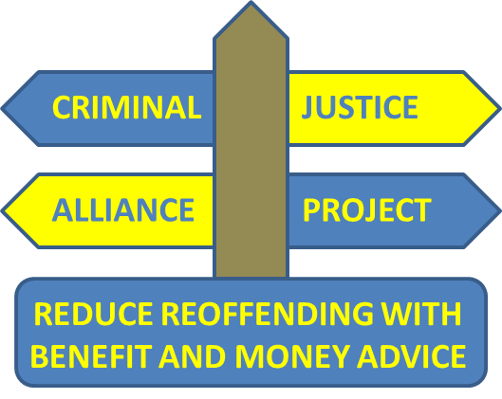
Criminal Justice Project

Alliance project workers provide advice on money, entitlements and help with practical issues will contribute to a reduction in offending. Jane Freck on 07817 024365 or email janefreck@stirlingcab.casonline.org.uk


Mental Health Money and Benefits Outreach Project

Specialist outreach Benefits and Money advice service provides advice and ongoing support to vulnerable people experiencing long term mental ill health. Referral is via your GP or Mental health professional.

Armed Services Advice Project

Funded by Poppy Scotland, this service provides specialist advice and support to the Armed services community and their dependants. Ally Gemmell on 07580 811207 or email allygemmell@stirlingcab.casonline.org.uk

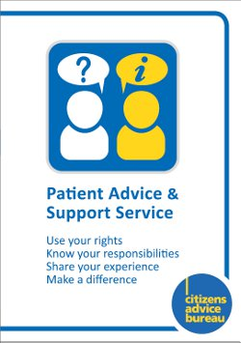
Patient Advice and Support Service

Specialist advice and support to people in Stirling district who are experiencing difficulty with their NHS service. Referral is via this CAB.

 Forth Valley Rural Fuel Poverty Advice Project

Fuel poverty - advice and support to enable people to take appropriate action to manage their fuel usage, access cheaper tariffs, receive advice on energy use and fuel debts. Kenny McKaig on 07580359643 or email kennymckaig@stirlingcab.casonline.org.uk

Forth Valley Addiction Advice Project

 CAB Addiction Advice project workers provide advice on money, entitlements and help with practical issues that will contribute to a reduction in alcohol and drug misuse.
Pension Wise

Specialist information and guidance to people in relation to their options linked to defined contribution Pension and related financial issues.


Pro bono Legal Clinic

Stirling CAB provides free legal advice, with 6x20 minute free solicitor interviews every fortnight. Referral is via Stirling CAB.

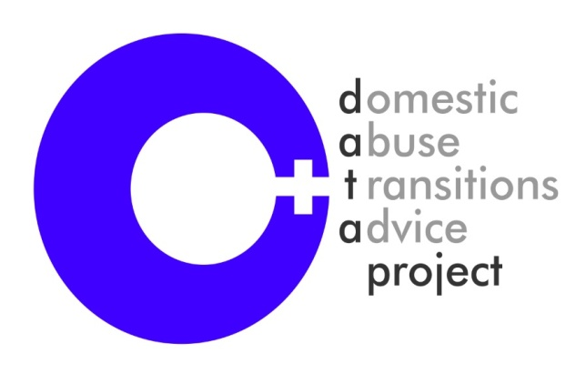  Domestic Abuse Transitions Advice Project

Free legal advice and support for women experiencing domestic abuse to become safer, healthier and happier.
Gillian Baker 07958 220295 and email is gillianbaker@StirlingCAB.casonline.org.uk

Specialist welfare rights, housing and debt advice for women experiencing domestic abuse to become safer, healthier and happier. Lesley Hunter 07958220296 and email is lesleyhunter@StirlingCAB.casonline.org.uk –



Financial Capability Advice Project (SKINT)

Help to resolve debt, maximise income, and help to better manage money, build financial capability and address financial exclusion. Help with and banking and access to cheaper deals. Jacqui Gibson on 07580638443 or email
jacquigibson@stirlingcab.casonline.org.uk

Stirling District Citizens Advice Bureau Ltd

Is a company limited by guarantee with charitable status
Company No - 126241 and Charity No – 007270

Main Bureau – advice line 01786 470239 + admin 01786 451225
www.stirlingcab.org.uk

Core Advice Service - open door hours Monday to Thursday 10 am to 3pm
Telephone advice available 9am – 8 pm Monday to Friday and 10am - 2pm Saturdays


