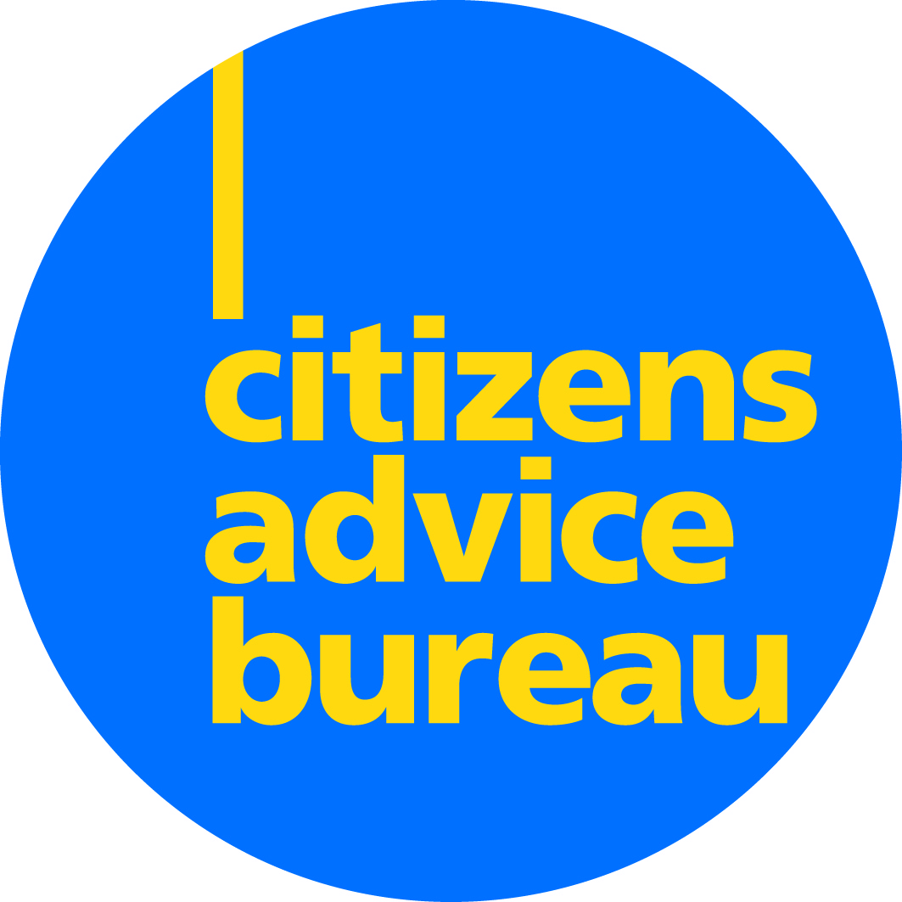
PERTH CITIZENS ADVICE BUREAU
Information to applicants

Citizens Advice Bureaux are the major providers of information, advice and assistance, operating from over 200 service points that cover Scotland from the islands to the City Centres.

All bureaux are members of Citizens Advice Scotland (the Scottish Association of CABx), and as such must meet specific conditions of membership related to standards of service and other matters. All bureaux are independent charities governed by a management board.

Perth CAB is based in the city of Perth but covers a large rural area with a diverse population. We currently employ 29 paid staff and we have over 30 volunteers, providing a wide range of services. Last year the bureau provided advice to over 7600 clients through 28384 client contacts. We dealt with 22,511 issues and achieved over £5.4 million in client financial gains.

The bureau operates a number of projects including Help to Claim for Universal Credit application support, Financial Inclusion projects with both the Trussell Trust and Perth and Kinross Council; Patient Advice and Support Service (PASS) for NHS patients and their families, Energy Advice Project, Welfare Benefits projects, Pension Wise which provides guidance on defined-contribution pensions and co-located services including at Murray Royal Hospital.

Since March 2020 Perth CAB has been delivering services remotely via telephone, email and limited video calls. Following a service review we have developed our 2021 – 2023 Strategic Plan and have identified the need for robust remote service delivery methods and infrastructure for home working long term. We recognise that COVID-19 has meant that we have to deliver our services differently and welcome the opportunity that these changes bring.

CAB Charity No: SC003259

