
Renfrewshire Citizens Advice Bureau

Renfrewshire Citizens Advice Bureau (RCAB) is an independent advice giving agency, a Company Limited by Guarantee and a Scottish Registered Charity.

The bureau which is based in Paisley was established in 1980, and is governed by a Board of Directors consisting of local residents and local group members. The front line service is delivered by trained volunteers who provide a Free, Impartial, Independent and Confidential advice and information service to the residents of Renfrewshire.

Renfrewshire has a population of almost 175,000, Paisley being the largest area within, with a population of 75,500.

The bureau currently has 11 full time and 8 part time members of staff, with 35 volunteers. The staff provide a service to a number of projects and core services which include.

Armed Services Advice Project
Financial Inclusion
Greater Renfrewshire Advice on Debt and Eviction
Housing Advice
Money Advice
Money Advice Service (MAS)
Outreaches:- Renfrew x 2, Johnstone, Erskine, Foxbar, Paisley, Linwood x 2 , Ferguslie, Bridge of Weir, University of West of Scotland, Victim Support plus Home Visits.
Patients Advice & Support Service

The main office is very busy and last year (2014-15) dealt with 17057 new and ongoing issues. This is a 17% increase from 2013-14. We advise on multi faceted enquiries with the largest enquiry area being Debt which accounted for 36.66% of the enquiry total.

Like every CAB in Scotland RCAB is a member of the Scottish Association of Citizens Advice Bureaux and is subject to a Bureau Evaluation every 3 years.
The evaluation covers every aspect of the CAB from Governance to Quality of Advice. The quality of advice assessment is a major part of the evaluation and ensures that the bureau is working to the aims of the service which are;

“ to ensure that no individual suffers through lack of knowledge of their rights and responsibilities, or of the services available to them, or through an inability to express their needs effectively “

And equally...…

To exercise a responsible influence on the development of social policies and services, both locally and nationally.

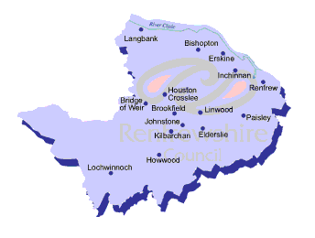
Scottish Charity Number SC00173845,
7 Glasgow Road Paisley PA1 3QS

