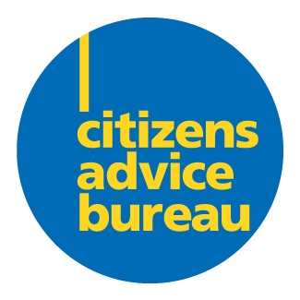
Parkhead Citizens Advice Bureau

Background Information

Parkhead CAB was established in 1990 to alleviate the effects of poverty, disadvantage and economic exclusion for the 124,000 people living in Glasgow’s east end by providing an information, advice, advocacy, negotiation and representation service to individual clients. The service is independent and provides free, confidential and impartial advice to everybody, regardless of individual circumstances.

The bureau currently provides services to clients through a mixture of drop-in services, appointments, home visits and outreach clinics. Our services are targeted to those clients most in need – people struggling on a low income, facing eviction or repossession of their property, experiencing ill-health or disability, dealing with unmanageable debt or facing the loss of a job. We provide a people-centred, holistic service with advice on rights and responsibilities together with a casework and representation service which aims to assist clients identify appropriate options, plan a course of action to resolve their problem and gain control of their situation. The advice services we provide are focussed on casework and representation, recognising that clients with complex and multiple-related problems need ongoing support and assistance.

As part of the delivery of a front-line advice service, we recruit and train local volunteers in advice work. All our front-line advice services are provided by trained and supported volunteer advisers. The role of paid staff is to provide the training and day-to-day support and supervision to enable volunteer advisers to deliver a high standard of service, and to monitor and progress complex casework and assist with representation services. Volunteer advisers benefit by gaining transferable skills and workplace experience and many move on to paid employment.

A high proportion of client feedback links our assistance with improvements in health, particularly helping to reduce stress levels.

Parkhead CAB is working in partnership with four bureaux in Glasgow and Castlemilk Law Centre on a joint SLAB funded project providing welfare rights advice and representation services.

Parkhead CAB has worked with four bureaux in Glasgow to develop a CAB solicitor service, dedicated to providing a second tier legal advice service and solicitor representation for CAB clients as well as specialist training and support in social welfare law for CAB advisers.

Parkhead CAB provides fundraising and capacity building support for local and national third sector organisations.

Parkhead CAB is a Scottish charity and a company limited by guarantee, and is managed by an experienced Board of Directors comprising local people representative of the community served and representatives from local voluntary organisations.

~ Tackling Poverty ~ Promoting Social Justice ~ Supporting Volunteering ~
~ Encouraging Learning & Development ~ Strengthening the Third Sector ~

