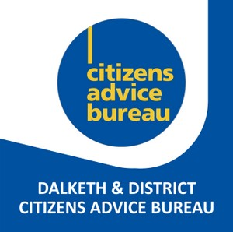
Dalkeith CAB
Equal Opportunities Monitoring Form

Role Title

Our CAB is striving to ensure equality of opportunity in employment, volunteering, governance and service delivery. We would like to know whether the widest range of people possible are engaging with CAB so we can identify ways of attracting more people who are not currently represented.

Your co-operation in completing this form is greatly appreciated. Information provided will be regarded with strict confidentiality and be processed in line with requirements of the Data Protection Act 2018. We will only retain information as long as legally required and will disclose no information to third parties that could lead to the identification of any individual. You are not obliged to complete this form or complete all questions within it. Your responses or your choice not to respond, will not affect the application process. Thank you.

Ethnic Identity. How do you describe yourself?

Choose ONE section from A to F, and then tick the appropriate box

A Asian or Asian British
Bangladeshi
Indian
Pakistani
Any other Asian background, please write in box .......................
B Black or Black British
African
Caribbean
Any other Black background, please write in box .......................
C Chinese or other ethnic group
Chinese
Any other, please write in box .......................
D Mixed Heritage
White and Asian
White and Black African
White and Black Caribbean
Any other Mixed background, please write in box ......................
E White
British
English
Irish
Scottish
Welsh
Any other White background, please write in box ......................
F Prefer not to say

Disability monitoring. To make positive changes, the CAB wants to address the different barriers faced by disabled people. This may include making reasonable adjustments to enable you to volunteer.

What do we mean by disability? Do you have a physical or mental impairment? Is it long term? Does this make it difficult for you to do the things that most people do on a fairly regular and frequent basis?

Disability

Do you consider yourself to have a disability or a long-term health condition?
Yes No Prefer not to say

If yes, what is the effect or impact of your disability or health condition? Prefer not to say

If you would like to discuss your response, or are unsure of the types of reasonable adjustment that might be possible, please contact the bureau manager in confidence.

CAB is committed to creating an environment where barriers are removed for disabled people and they can give of their best to succeed in our organisations.
This information will remain confidential within HR.

Gender identity

Would you describe yourself as:
Man Woman Other gender identity Prefer not to say

Please provide any further information on your gender identity if you wish:

Sexual orientation

What is your sexual orientation?

Bisexual
Gay man
Gay Woman / Lesbian
Heterosexual / Straight
Other
Prefer not to say

Age

What is your age range?

<20
20-24
25–29
30-34
35–39
40-44
45-49
50-54
55-59
60-64
65+
Prefer not to say

Religion and belief

Please tick the box that best describes you:

Buddhist
Christian
Hindu
Sikh
Jewish
Muslim
Other (please state below) ............................
No Religion
Prefer not to say

