
Stirling District Citizens Advice Bureau Ltd

Information

What Stirling CAB does for Stirling Citizens
The ever changing welfare reforms and the economic downturn have created a huge and increasing demand for your local CAB services. In order for the CAB to continue to help people in Stirling District, its staff and volunteers have had to develop and create an organisation that both meets the need of the community and is cost effective to the taxpayer. The CAB service in Stirling is a charity and relies on core funding from local government and a range of innovative project funders to exist to help protect and improve the quality of life for vulnerable people in the Stirling area.
Stirling CAB delivers free, confidential, impartial and independent information, advice, and support and representation services to the citizens of the area regardless of their age, race, religion or belief, sexual orientation, disability, gender or any other social factor. Information, advice and support are provided on a very wide range of issues, with the greatest demand relating to welfare benefits, employment, consumer debt, housing and legal issues.
The Bureau strives to deliver services that are efficient and effective, provide value for money, are fit for purpose and meet client needs as fully as possible. The mixture of city, towns and rural villages present particular challenges in terms of service configuration and delivery which are being met using a variety of different approaches to suit local need.
For example, Stirling CAB provides outreach clinics in a variety of different rural locations and settings as well as a home visiting service for housebound people, as outreach is not always a viable option. It also offers email and telephone advice, and refers clients, as appropriate, to the service’s web-based information and self-help resource, Advice Guide.
Stirling CAB is a highly respected, valued and trusted brand and provides a holistic service which aims to meet all of a client’s needs. It works in partnership with a number of agencies including Stirling Council, Women’s Aid and Criminal Justice to deliver welfare rights, employment, money, housing and legal advice but does not operate in competition with any of these organisations.
The Bureau currently has over 60 highly skilled volunteers and a small team of Core and Project staff designed to meet the advice and support needs of the community:

 Core Advice Service
This service provides at least 100 hours per week face to face advice, telephone and email advice, information and casework support up to but excluding a physical appearance at court or tribunal. This covers the following subjects: Welfare Benefits, Consumer issues, Debt, Education, Employment, Finance, Housing, Health, Immigration and Nationality, Legal, Relationships, Utilities.
Last year Stirling CAB dealt with 13 358 varied issues and generated £3.75 million into the pockets of people in Stirling. It also resolved £3.6 million worth of debt for the community.
 Money Advice Service
Stirling CAB delivers Money Guidance in Stirling – in partnership with community organisations and Housing Associations - and offers advice on budgeting and money issues in relation to change of circumstances. It also clearly explains issues on finance. Since 2012, it has assisted over 600 people.
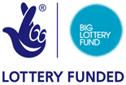 CAB/Criminal Justice Alliance Project
This new Big Lottery Support and Connect funded project will allow Stirling CAB and the Council’s Criminal Justice Service to work together. The two specialist Benefits and Money Advice Service workers will reduce the impact of welfare reforms on vulnerable people involved in the Criminal Justice system and provide a second tier advice support service to Criminal Justice workers. Advice on money, entitlements and help with practical issues will contribute to a reduction in offending.
Representation at Tribunals
Stirling CAB and Stirling Council on Disability have made a joint proposal to Stirling Council to provide a Best Value representation service to help the huge number of vulnerable people in Stirling District losing benefit entitlement due to Welfare reforms. Stirling CAB currently does not offer a routine type 3 service.

BIG – Financial Capability Project (Eastern Villages/Raploch/Cornton/Cultenhove/ Cowie/Callander) – The SKINT campaign
Stirling CAB secured funding for the Financial Capability Advice Project from BIG Lottery Investing in Communities in 2012 ( this funding runs till 2017) This SKINT campaign has generated over £600,000 into some of the most deprived communities in Stirling District thus far. It provides weekly advice surgeries and home visiting in Stirling District’s rural communities. The project has also taught over 1000 vulnerable people to better understand and manage money. They have also ensured that those without bank accounts get them and that people access the best and cheapest deals on the market for credit, for gas and electricity and for insurance.
This service is expanding into more rural Stirling in 2014/2015 and in addition to Plean, Cowie, Cultenhove, Cornton has opened ( or shortly will) advice sites in Callander, Killin and Balfron.
Case evidence – The client fled from domestic violence and had been placed in temporary housing accommodation.
The client’s sole income was welfare benefits and her income was further depleted by the introduction of the bedroom tax; the client’s temporary accommodation was a 3-bedroom property, meaning that she had to pay £27 per week from her £71.60 per week. The client also had deductions being taken from her ongoing benefit award to clear her rent, council tax and social fund arrears.
The Bureau was able to obtain emergency funds for the client so that she could put money into her electricity meter. The client was also given a charitable grant from a charity to apply for her own bankruptcy (£200).
The client was declared bankrupt, thus clearing her debts (totalling around £5,000). Without rent arrears, the client was finally offered permanent accommodation after being in homelessness accommodation for a significant length of time.
Volunteers into work
Stirling CAB helps unemployed people get paid jobs. Last year, through our training and volunteer support work, 40 - 60% of our volunteers got a job within 12 – 18 months of joining the CAB.
Translators
As Stirling is a multicultural city, and Stirling CAB an inclusive organisation, it offers advice in Polish, Russian, Latvian, Chinese, Braille and British Sign Language.

 Mental Health Money and Benefits Outreach Project
Jointly funded by Stirling Council and NHS Forth Valley this specialist outreach Benefits and Money advice service provided advice and ongoing support to vulnerable people experiencing long term mental ill health at a variety of locations throughout Stirling. It put £178,000 into the pocket of some of the most vulnerable people in our community and stopped hundreds having to access emergency NHS psychiatric support.
Case evidence - A client was referred to the CAB Mental Health Project with a range of acute psychiatric problems, resulting in their admission for detention under the Mental Health Act by their psychiatrist.
The Mental Health Project conducted a full benefit check. The client had a history of cancelling their benefit awards. These were always taken as verbatim by DWP as the client stated they were fit for work; as a result all entitlements stopped.
The Mental Health Project constructed a case with supporting letters regarding the client’s condition history and diagnosis from CPN and Psychiatrists.
All relevant benefit forms were completed, submitted and rejected, despite the client being accompanied to their ATOS medical. The decisions were appealed, and the cases constructed and submitted to tribunals by the Mental Health project which resulted in all entitlements being reinstated. This put over £11,550 back into this vulnerable person’s pocket.
Women’s Aid outreach surgery
Stirling CAB currently provides a specialist advice service at Stirling Women’s Aid office to those women and children experiencing domestic abuse.

Domestic Abuse Transitions Advice Project
We have recently been awarded funding from BIG Lottery – Becoming a Survivor fund for a five year (two worker initiative- a CAB Women and Children’s Solicitor and a CAB paralegal Domestic Abuse caseworker .The DATA project aims at pulling together individualised legal advice, information and casework support tailored for women and their children fleeing domestic abuse; it will contain all or some of the range of support below.
• FREE Legal advice, representation and social/welfare holistic casework support
• One to one support/advocacy
• Volunteer Befriending scheme (Women’s Aid)
• Support with benefits, legal advice and housing options
The DATA project is a necessity in order for a woman to break the cycle of abuse, solving many of the practical issues that inhibit leaving and providing holistic support to the family to look forward and plan for the future, set goals and work towards these goals leading to improved confidence and resilience.
Work Club
Stirling CAB via the SKINT outreach project runs successful Work Clubs in Plean, Cowie and now Callander, helping local unemployed adults back into work.

 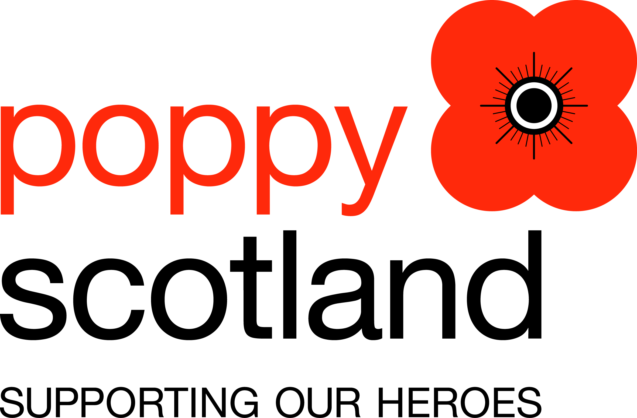 Armed Services Advice Project (ASAP)

Stirling CAB secured funding from Poppy Scotland and provides specialist advice and support to the Armed services community and their dependents. In the last year this project has helped over 240 veterans with a range of welfare, debt, employment, housing and mental health issues and generated over £250,000 for some of the most vulnerable people in our community. A pertinent quote by a veteran client:
“Serving in Afghanistan is easier than understanding Civvy Street”

Case evidence – A Veteran with Post Traumatic Stress Disorder was sacked by his employer for gross misconduct. The ASAP project submitted the relevant arguments through an Employment Tribunal claim. Employer lawyers repeatedly tried to strike out the claim over the course of several pre-hearing reviews that ASAP represented. ASAP argued the case and the Tribunal ordered an independent psychiatric report. As a consequence of the report the employer sought settlement out of court, which was accepted. Using the report, ASAP applied for a war pension and Disability Living Allowance. A war pension was awarded as was DLA. This was a prolonged case over two years and the client financial gain for 1 year was £7500.
Pro bono legal clinic
Stirling CAB provides free legal advice, with 6 x 30 minute free solicitor interviews every fortnight.
Patient Advisory Support Service (PASS)

Stirling CAB provides a specialist advice and support service to people in Stirling district who are experiencing difficulty with their NHS service and wish to raise concerns or complaints. This service includes compensation and actions for medical negligence.
 Stirling CAB Rural Fuel Poverty Outreach Project
Fuel Poverty is a big problem and, with the electricity and gas price increases, it’s getting worse. Stirling CAB’s Rural Fuel Poverty Project funded from June 2014 by Scottish Southern Energy, is a response to help educate and inform, enable and empower people in rural Stirling District to take appropriate action to manage their fuel usage. It also helps them cope via energy efficiency advice and instruction, and access to energy related grants and products that use less energy.
This project will look to deliver Community workshops to both frontline workers and service users to provide practical assistance in obtaining cheaper electricity and gas. It will also offer weekly outreach and home visiting to vulnerable people who may be housebound in rural Stirling District.

Social Policy Team
Our volunteer researchers have produced reports, research, factsheets and guides for vulnerable people in the community. This year, both the Crisis Survival campaign – “Got no Money, Got no Food”- and the Homelessness - “Know your rights“ - activity were very successful. Our next campaign – “Under Pressure “focuses on the problems clients have in relation to medicals and obtaining medical evidence linked to the increase due to Welfare reform. This evidence-based work helps influence local and national policy to be fairer on local people and is of significant use to local councillors, MP’s and MSP’s to help them interpret how legislation impacts on in their constituency.
Final Note
The Poverty Alliance predicts that over £27 million will be removed from the Stirling District economy linked to Welfare reforms (2012 – 2015). For this reason and many others, Stirling CAB exists as a vital Best Value service to our community and informs, enables, empowers and protects vulnerable people in Stirling District, and is needed now more than ever before.

