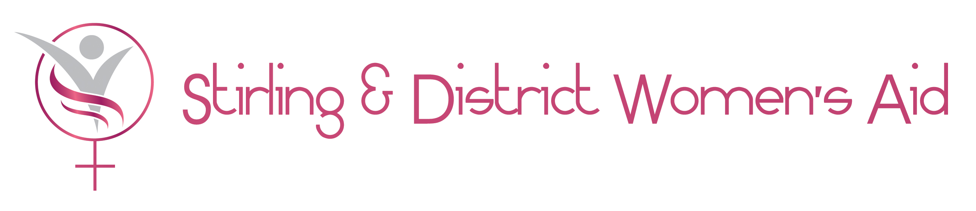

Stirling District Citizens Advice Bureau Ltd

Domestic Abuse Transitions Advice Project (DATA) 

The DATA project is an innovative pilot collaboration between Stirling CAB and Stirling District Women’s Aid (SDWA). The Project has received a 5yr funding award by the BIG Lottery Becoming a Survivor fund.

The DATA project is designed to address the need for comprehensive support on financial management, social/ welfare advice and access to free legal advice and representation to women experiencing domestic abuse, to support and maintain their transition to a safer, happier, financially independent life free from abuse. The practical barriers to forward transition will be addressed by Stirling CAB and the emotional ones by Stirling District Women’s Aid (SDWA).

Both organisations complement each other highly in terms of their knowledge.

Stirling CAB will provide information, advice; representation services and casework on practical issues that will assist the client establish and maintain an independent life after leaving the abuser (benefit entitlement, debt management advice, housing rights, free legal advice and representation – interdicts etc). In order to do so effectively Stirling CAB will remain emotionally objective at all times.

Stirling District Women’s Aid (SDWA) will inform CAB and collaborate with the DATA project staff on the dynamics of domestic abuse, and provide the emotional support needed for the survivors of domestic abuse. SDWA will inform and support survivors what services are available to assist a survivor in leaving an abusive relationship.

The partnership provision of SDWA and CAB (DATA) will compliment the forward motion of the survivors of domestic abuse with SDWA addressing the emotional barriers to forward motion and the CAB (DATA) removing the practical ones.

The DATA projects capacity will be increased by CAB (practical advice /legal advice) and SDWA volunteers (emotional advice/emotional support) working alongside the paid staff.

Stirling District Citizens Advice Bureau Ltd (Stirling CAB) is the lead organisation for the Domestic Abuse Transitions Advice Project (DATA), it will be the sole employer of both the Women and Children’s Solicitor and the DATA caseworker and it will have sole responsibility in delivering the DATA project. Stirling CAB will operationally manage the project in accordance with the DATA Steering Group’s strategic direction; and Stirling CAB will be singularly responsible for the evaluation, monitoring and reporting to BIG on the activities of the DATA project, fully compliant within Becoming a Survivors , timescales, terms and conditions.

Contact details of the lead organisation

Craig Anderson
Bureau Manager
Stirling District Citizens Advice Bureau Ltd (lead organisation + employer)
Norman MacEwan Centre for Voluntary Organisations
3 Cameronian Street
Upper Craigs
Stirling
FK8 2DX
craiganderson@stirlingcab.casonline.org.uk
01786 464773 (ex directory)

Contact details of the partner organisation

Jessica Lindhof
Director
Stirling District Women’s Aid (main referral source to DATA project + emotional/counselling support to DATA clients + support in kind)
Unit 7
Stirling Arcade
Stirling
FK8 1AX
Jessica@stirlingwomensaid.co.uk
01786 469518

Roles and responsibilities

SDWA will offer advice and emotional support and counselling to the “survivor and their children”, initially and throughout the recovery process, to address the emotional barriers to secure a sustained transition to a safer/happier life free from abuse. The vast majority of referrals to DATA project will come from SDWA following their initial engagement with the survivor.

CAB (DATA) staff will offer emotionally objective practical legal advice and holistic casework on social/welfare issues to the “survivor and their children”, initially and throughout the recovery process, to address the practical barriers to secure a sustained transition to a safer/happier life free from abuse.

SDWA will offer support in kind (office space, photocopying, and expertise) to the DATA project and will work in a collaborative / complimentary case conference based approach to our mutual clients.

