scab.org.uk
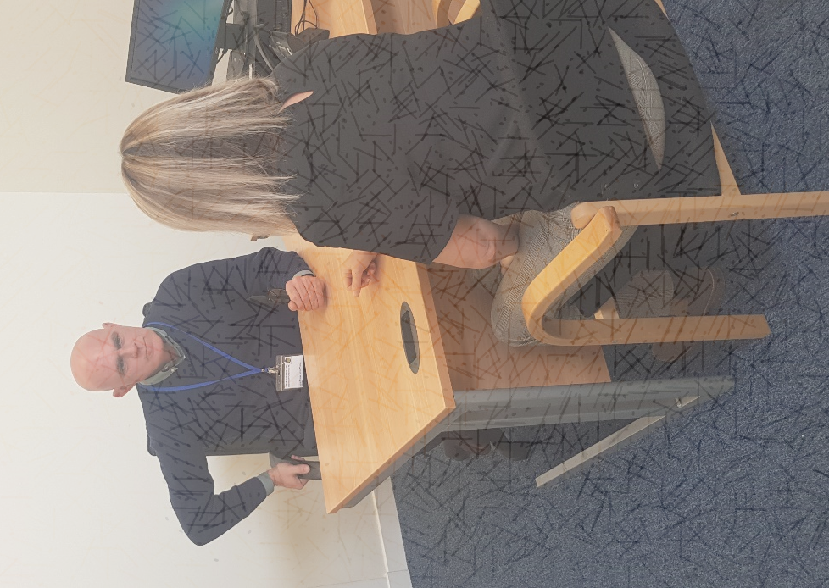

Working with us:

Specialist Housing Adviser
Clackmannanshire Landlord and Tenant Advice Mediation and Support Service

Contents

A note from our Managing Director, Jonny Miller

About Our Bureau

About the Role

Job description

Person Specification

How to Apply

A note from our Bureau Manager

“Thank you for your interest in joining the Clackmannanshire Citizens Advice Bureau Team. Our employees and volunteers play a critical role in helping the people of Clackmannanshire get the advice, help and support they need.

We hope this pack will give you the information you need to decide if a role with us is right for you. We rely on each member of the team to bring their own unique skills, experience, views and commitment to our goals – it’s that combination which makes our organisation what it is.

The Clackmannanshire Citizens Advice Bureau gives much-needed advice and information to people from all walks of life, on a huge range of issues. We give advice – face to face, online and by telephone. The services we provide make a difference in communities across Clackmannanshire, ensuring people are aware of their rights and responsibilities. We look forward to hearing from you if you decide to apply and to learning more about what you can bring to this role, and to the team.”

Jonny Miller, Managing Director
Clackmannanshire Citizens Advice Bureau
Specialist Housing Adviser Job Pack, Clackmannanshire Citizens Advice Bureau

About Our Bureau

The Clackmannanshire Citizens Advice Bureau Service was established in 1967 and funded by Clackmannanshire Council, with a service level agreement in place. The aim was to provide free, confidential, impartial and independent advice. Since then, we have grown significantly and now have a team of 27 paid and 21 volunteer staff. In addition to our general advice service, we have 18 additional projects (find out more: www.clackscab.org.uk).

We are a volunteer led organisation. All volunteers undergo a comprehensive training course before working as advisers.

We have a strong volunteer Board of Directors who provide governance support to the Managing Director and staff/volunteer team. We are a registered charity and company limited by guarantee.

We are affiliated to Citizens Advice Scotland which has opened many doors for us, giving us access to training, funding and IT support to name a few. Each year demand for our services has increased. People of Clackmannanshire can receive General Advice and also more specialist advice from a number of projects, some national, some regional and some local. These projects include Patient Advice, Help to Claim (Universal Credit), Welfare Rights, including Money Advice, Welfare Reform, Housing Debt, Financial Health Checks, Energy and Debt. We offer a number of outreach services in locations across the county and a home visiting service. We are accredited to Type III in Scottish National Standards for Advice providers by the Scottish Legal Aid Board (most recent audit December 2021), this is the highest accreditation available in the areas of Housing, Welfare Benefits and Money Advice. We are a progressive organisation with a strong focus on social policy work, as we hope to influence decision making at both local and national level.

We rely on local Authority and external trust funding and donations to fund all of our service. All Citizens Advice Bureaux are independent and have their own Board of Directors and sources of income.

Between April 2022 and March 2023, we worked with 5,074 clients on 12,700 occasions and helped resolve 33,800 issues. During this period, we enabled clients to access £2.17 million in the form of successful benefit applications and appeals, debt write offs, grant applications, employment issues, and securing charitable support, energy efficiency, housing and much more. In addition to our core funding from Clackmannanshire Council, we regularly seek other sources of funding to ensure that we meet the growing complex demands for advice.

Every day is different in our office and we hope that you would find the advertised role to be both challenging and rewarding.

About the Role

Job Title: Specialist Housing Adviser (Clackmannanshire Landlord and Tenant Advice Mediation and Support Service)

Responsible to: Deputy Manager

Hours: 35 Hours per week (fixed term for one year with possible extension, subject to funding)

Location: Based at Clackmannanshire Citizens Advice Bureau (Alloa)

Salary: Up to £27,500 (Dependant on experience)

Closing Date: Friday 7th July 2023 at 4pm

The Specialist Housing Adviser will work under the new project, Clackmannanshire Landlord and Tenant Advice Mediation and Support Service. The adviser will help private tenants to remain in their current property through the provision of income maximisation, debt advice, energy efficiency advice, mediation and representation in courts and tribunals, where required.
Budgeting and money management skills will also be provided by the adviser to empower private tenants to manage their budget effectively. It is essential that this role contributes to the development of good working relationships between landlord and tenant within the area. This project will have a significant focus on education of both landlords and private tenants. To encourage good practice, landlords will be offered specialist advice relating to property condition, safety requirements, deposits, anti-social behaviour, arrears and eviction. In addition, the adviser will be responsible for the development of a local Private Landlord Forum.

Job description

Key responsibilities

To conduct face-to-face, telephone and email interviews, using sensitive listening and questioning skills to allow clients to explain their problem(s) and empower them to set their own priorities.

- To explore clients’ circumstances, support their needs and channel preferences considering language barriers, accessibility needs
- Assist private tenants by making them aware of their rights and the responsibilities of being a tenant
- Carry out Financial Health checks with private tenants to ensure income maximisation & explore budgeting efficiencies
- Inform tenants of any financial help they will be entitled to, assisting with on-line Scottish Welfare Applications to assist with rent deposits and furniture as well as accessing grants to assist with energy issues
- Provide assistance to private tenants facing eviction (& other issues) through negotiation and mediation with the landlord
- If required, provide representation at first tier tribunal or courts
- Work with private landlords/Tenants and Residents Federation to revisit the resurrection of the Private Landlords Forum within Clackmannanshire to share best practice
- Provide workshops to private landlords in Clackmannanshire to make them aware of their legal obligations towards their tenants to include reference to all associated paperwork & tenancy agreements
- Put in place a direct referral system allowing us to work with both the tenants and landlords to achieve a mutually agreeable solution
- Work closely with statutory and third sector agencies to publicise the project
- Publicise the project through social media e.g. Facebook, Twitter and website and through distribution of flyers, leaflets
- Design of a private tenants guide for distribution to private tenants in Clackmannanshire
- Provide required reports in conjunction with Deputy Manager to Safe Deposit Scotland trust
- To record, update and maintain information on our case management system for the purpose of continuity of casework, information retrieval, statistical monitoring and report preparation
- Collaborate with our SGN Safe and Warm Adviser to encourage private landlords to comply to CO safety legislation
- Provide energy efficiency advice and refer consenting private landlords to support available through Home Energy Scotland
- Keep up to date with changes in legislation effecting Private Tenancies & provide training as appropriate to various parties
- Establish links with Clackmannanshire Council in relation to Private Landlord registration.
- Take part in working groups set up by Clackmannshire Council in relation to reviewing the Housing Strategy

The above job description is not exhaustive and is clarified to include broad duties inherent in the post, as reasonably requested by the Managing Director of the Bureau.

Person Specification

Essential

- Educated to degree level or have equivalent relevant experience
- Minimum 3 years work experience in office systems and procedures
- Experience in housing related advice to Type III Scottish National Standard
- Good awareness and understanding of how rights and advice issues impact on the local communities and understand the issues involved in interviewing clients
- Experience in carrying a complex caseload
- Working knowledge of court/ tribunal procedures in relation to evictions and housing related matters
- An excellent working knowledge of welfare benefits and better off calculations
- Effective oral and writing skills including through IT with particular emphasis on negotiating, representing and preparing reviews, reports and correspondence
- Ability to prioritise own work, meet deadlines and manage caseload and an ability to work under pressure when immediate action is required
- An innovator who likes the challenge of developing and implementing new approaches
- Ability to give and receive feedback objectively and sensitively and a willingness to challenge constructively
- Excellent team player
- Demonstrate understanding of social trends and their implications for clients and service provision
- Willing to be flexible and adaptable in meeting the needs of the service (occasional working out with office hours)

Desirable

- Experience of working in the advice sector
- Experience of working in the housing sector
- Ability to interpret complex legal issues and find solutions
- Experience in organising training programs
- Experience of undertaking research and/or consultation
- Experience of CASTLE case recording system
- Experience in representation in both debt and benefit related issues
- Awareness of the social needs of local communities and services provided by the voluntary sector
- Proven ability to work within a community development or volunteer setting
- Experience of partnership working in the voluntary and statutory sectors
- An in depth knowledge of local Private Rented Sector housing legislation
- A knowledge of homelessness procedures
- Understanding of and commitment to the aims and principles of the CAB service and its equal opportunities policies

How to Apply

To apply for this role, please send completed copies of the Application Form, along with
a covering letter to: eleanor.penman@clackscab.casonline.org.uk

We will shortlist for interview only based on the information provided within in the application form which demonstrate how you meet the requirements of the post. Please refer directly to the job description and person specification.

Equality & diversity monitoring: To help us monitor equality and diversity statistics, please return the Equality & Diversity Monitoring Form separate from your other application documents by emailing it to: jonny.miller@clackscab.casonline.org.uk

Clackmannanshire Citizens Advice Bureau
Glebe Hall, Burgh Mews, Alloa, FK10 1HS
Tel: 01259 219404
Email:bureau@clackscab.casoline.org.uk

Scottish charity SC001839 and company limited by guarantee SC493971

